Applied Microeconomics – Task 1
Ondřej Marvan
477001

- Photographed calculations

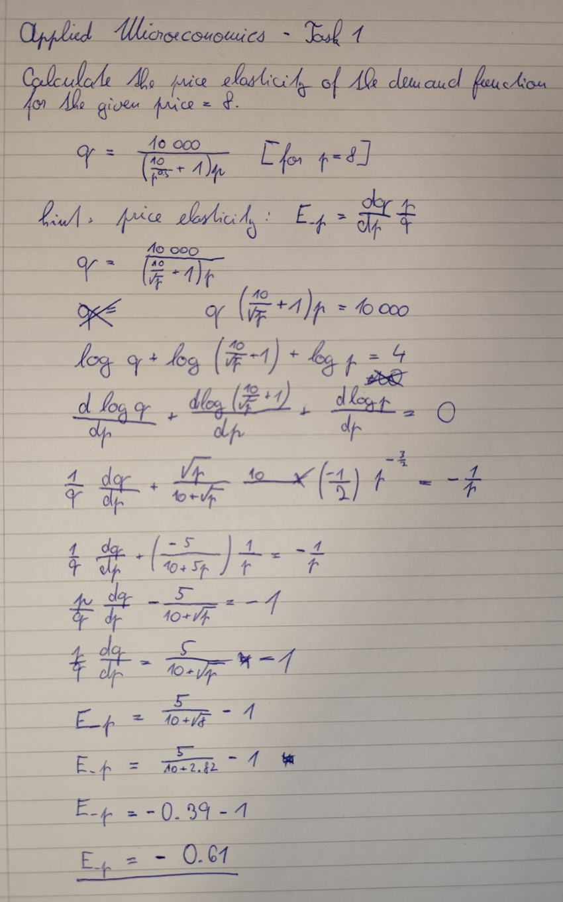
- A short comment - do you think these were difficult calculations, and what is your level of mathematical competence
It took me several attempts and a lot of Googling and revising of math to figure out the correct calculation.

- The result of using the Maxim code, which is used to calculate this type of task. Provide an interpretation of the result obtained

kill(all)$
q: 10000/(p*(1+(10/p^0.5)));
E_p: diff(q,p,1)* (p/q);
p: 8;
ev(E_p);
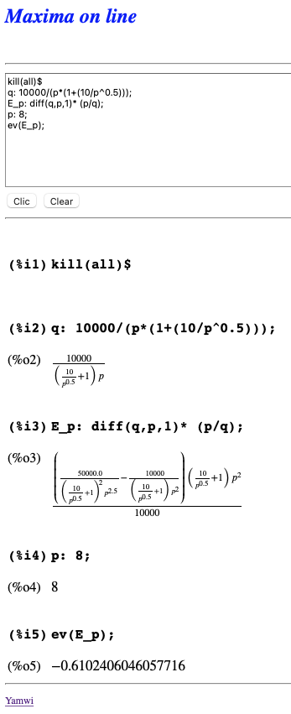

The calculated elasticity of E_p=−0.61 indicates that for a 1% increase in price, the quantity demanded will decrease by 0.61%. Since ∣Ep∣<1|E_p| < 1∣Ep​∣<1, this reflects inelastic demand, meaning consumers are relatively unresponsive to price changes. Such inelasticity suggests the product is likely a necessity or has few substitutes, and firms could increase prices without a significant drop in demand, potentially boosting revenue.

